LOG IN

SWIM Registry Usage Scenarios

Overview
This usage scenario covers the log in process.

UC001: Discovery of Registry Documentation

Precondition
The user requires an account as explained in the User Registration Scenario.

Outcome
The user logs in to the registry.

User Interaction
The user needs to execute the following actions.

Access LOG-IN Page
The user needs to :
- Go to registry home page http://dev.eur-registry.swim.aero/ and follow the link Log in.
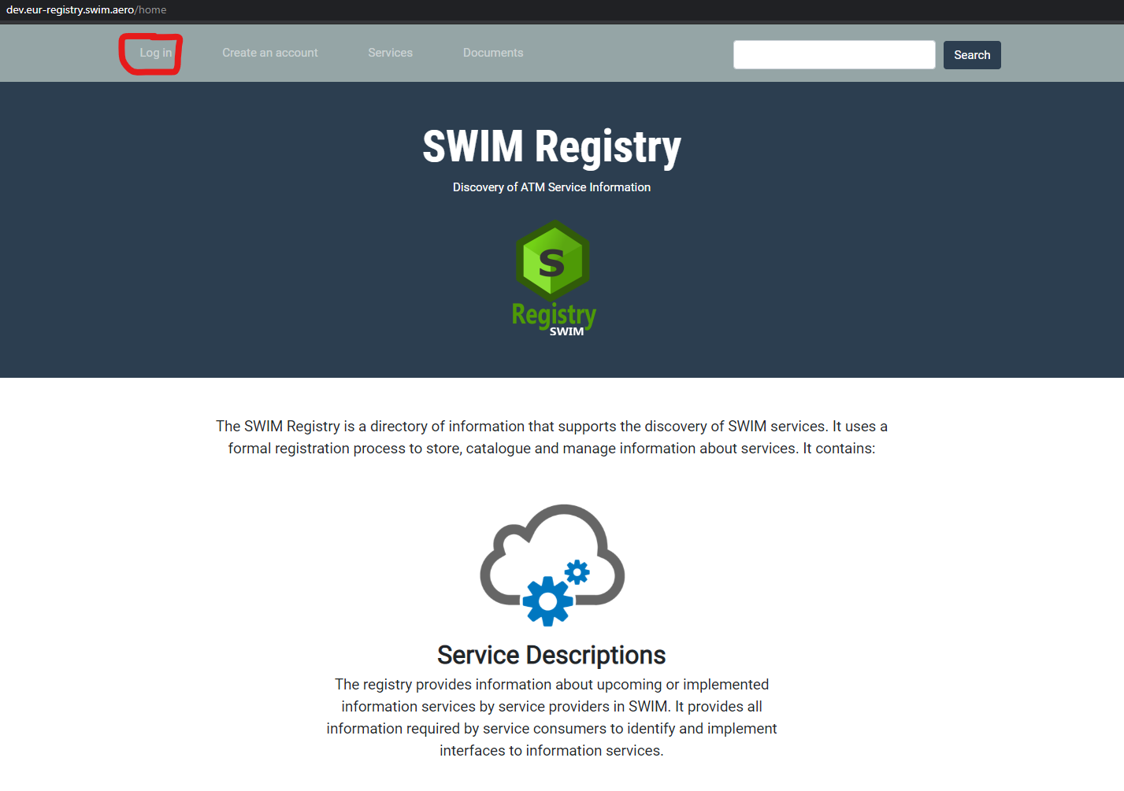

LOG IN
The user needs to:
- Provide UID/PWD and log in.
