authenticated Discovery

SWIM Registry Usage Scenarios

Overview
This usage scenario covers the discovery capabilities of the registry for authenticated users. It includes the following use cases:
- Discovery of registry documentation
- Discovery of all available services

UC001: Discovery of Registry Documentation

Precondition
Logged in

Outcome
The user retrieves documents related to the usage of the registry (e.g. user manuals)

User Interaction
The user needs to execute the following actions.

Access Documents Page
The user needs to:
- Go to registry home page http://dev.eur-registry.swim.aero/ and log in. Go to Document:
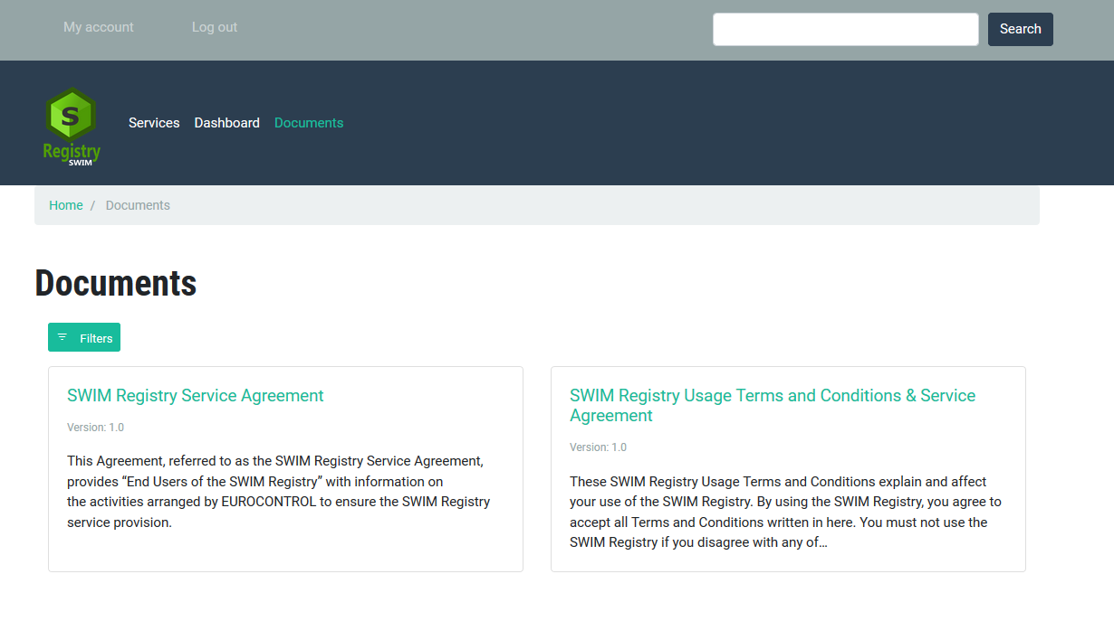

Filter and access the required document
The user needs to:
- Use the filter to restrict the number of documents to the required category.
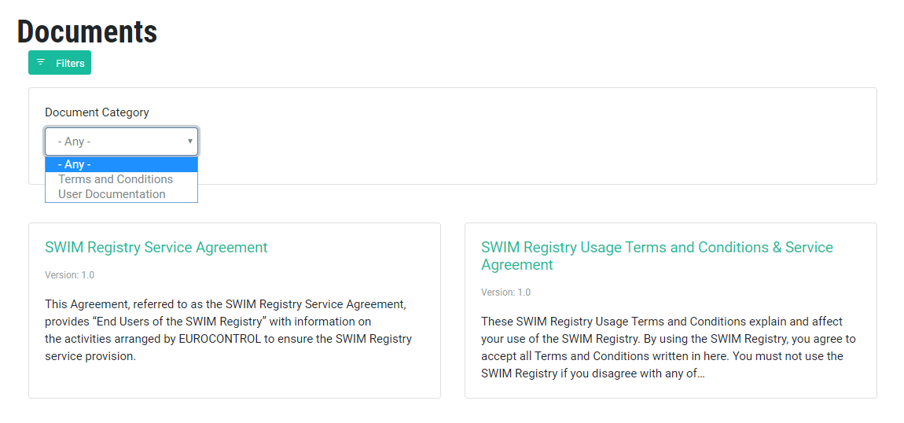

UC002: Discovery of SERVICES

Precondition
Logged in

Outcome
The user retrieves discovers and retrieves information describing services

User Interaction
The user needs to execute the following actions.

Access SERVICES Page
The user needs to:
- Go to registry home page http://dev.eur-registry.swim.aero/ and follow the link Services.
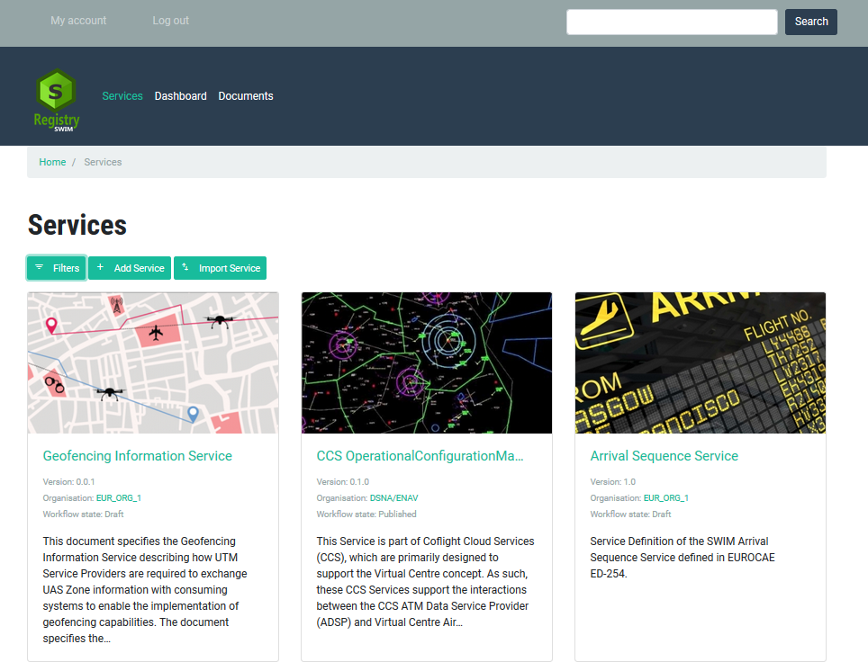

Filter and access the required SERVICES
The user needs to:
- Use the filter to restrict the number of services to the required category.
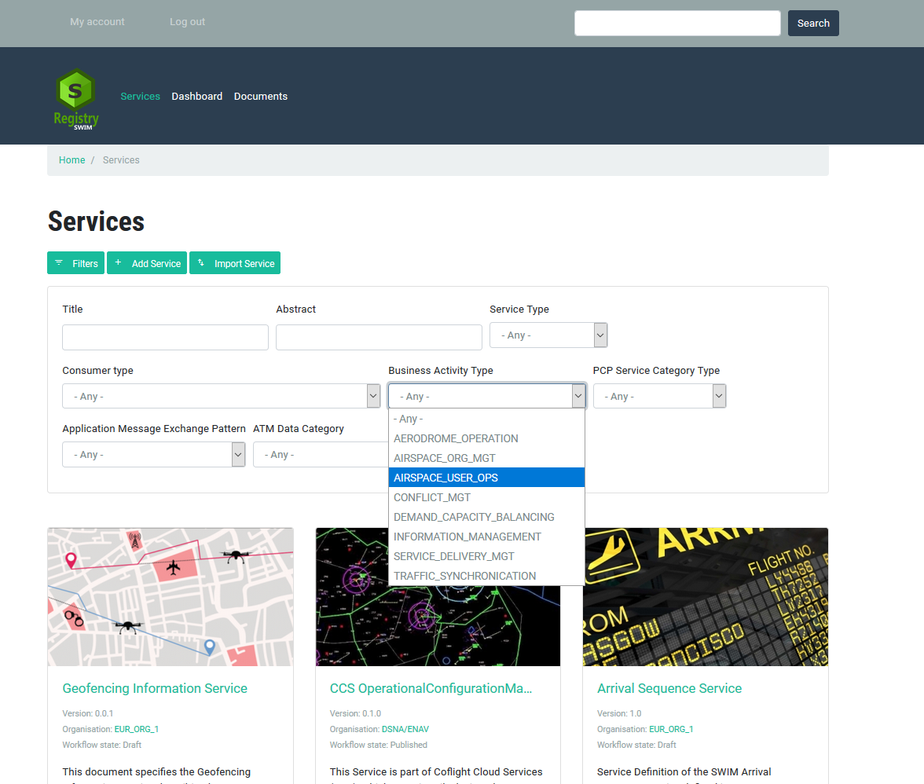

- Select the required service and get the required information.

